HPC research paper proposal draft

Notes
- Combining QPUs with classical high-performance computing can lead to a significant acceleration of technological innovation and computing speed, paving the way for a powerful computational future, so long as we can attain Fault-Tolerant Quantum Computing (FTQC)

- IBM's Qiskit and Google's Cirq, act as the primary interface for developers to design quantum circuits and execute them on simulators or actual QPUs.

- Domain-Specific Languages (DSLs): Other languages have been specifically created for quantum programming, such as Microsoft's Q# (Q-sharp)

- At the hardware level, quantum instruction sets (QIS) provide gate-level instructions that directly control the QPU's operations, similar to assembly language for classical computers. Examples include OpenQASM (IBM) and Quil (Rigetti)

- The transition from Noisy Intermediate-Scale Quantum (NISQ) to FTQC is critical, and it will happen sooner.

- Solving the software limitation conundrum will enable quantum routines to be integrated into HPC applications to study the real impact of hybrid algorithms

- Q-Pragma is a brand-new technology framework developed by Eviden’s Quantum R&D task force.

- seven criteria are code and memory locality, dynamic interaction, scalability, reversibility, controllability, safe uncomputation, and typing.seven criteria based on theoretical quantum algorithms and low-level quantum frameworks to ensure the framework is suitable for HPC applications.

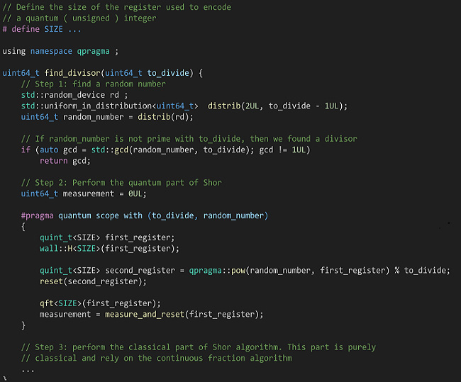
- Shor's Algorithm - designed for factoring large integers in polynomial time (O(log N)^3)
It represents a significant threat to modern cryptographic systems—specifically RSA—because it provides an exponential speedup over the best-known classical factoring algorithms, which operate in sub-exponential time.

Clifford+T - a universal, fault-tolerant quantum gate set commonly used in quantum error correction

Universality: Any quantum circuit can be approximated to arbitrary precision using only Clifford and T gates.

Fault Tolerance: In many fault-tolerant architectures, Clifford gates are implemented directly, while T gates are applied via magic state injection. - Fault-tolerant architecture enables systems to maintain continuous operation and avoid downtime despite component failures by using redundancy, replication, and automatic failover

Synthesis & Optimization: Quantum compilers often focus on reducing the “T count" (number of Tgates) to minimize circuit depth, as T gates are costly to implement.

ORNL team’s

Key innovations include:

Unified resource management system to coordinate classical and quantum workloads.

Flexible quantum programming interface that hides hardware-specific complexity.

Quantum platform management interface for easy integration of diverse quantum hardware.

Comprehensive tool chain for optimising and executing quantum circuits.

Qubits continue to lose coherence, researchers useare experimenting with different approaches – using neutral atoms, superconductors, trapped ions, and more – but no standard has yet emerged.

At its core is the idea of a quantum controller, a device that acts as an interpreter between a quantum processor and a supercomputer.

This controller would manage scheduling, prioritise data traffic, and ensure smooth performance across both platforms.

The unified resource management system would further streamline this coordination, preventing bottlenecks that could slow results.
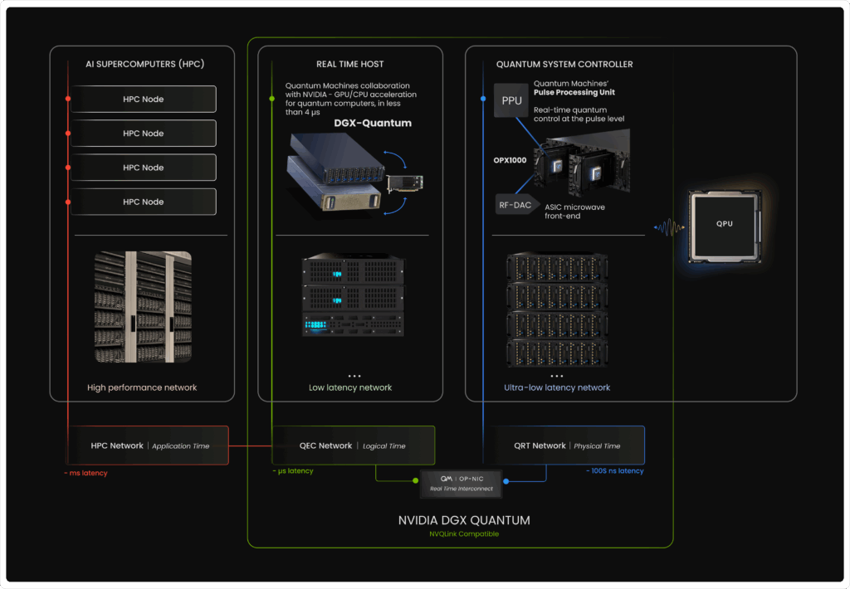

https://www.quantum-machines.co/the-architecture-blueprint-for-hybrid-quantum-classical-supercomputers/

Notes for the above paper

Main points -

- Ultra-low latency control (QRT network, ~hundreds of nanoseconds latency)

This tightest network connects the quantum controller to the QPU. Here the pulse processing unit (PPU) embedded in the OPX1000 shapes pulses, enforces deterministic timing, performs mid-circuit measurement, and applies feed-forward within the quantum runtime. The goal is to keep the control loop physically close to the device to allow feedback within hundreds of nanoseconds or less. Strict timing is essential in order to perform operations on qubits much faster than their coherence time. The regime where latency must be compared with qubit coherence is what we call Quantum Real Time (QRT This is how qubits operate together as a QPU, ready for integration with higher layers.

- Low-latency acceleration for decoding and calibration (QEC network, ~microseconds latency)

The middle network links controllers to dedicated acceleration servers that typically host GPUs and CPUs but can also include FPGAs or ASICs. This is necessary because with larger quantum systems comes the ever-greater need for powerful classical computation, for decoding, compilation, calibration, etc. With Quantum Machines-NVIDIA collaboration on DGX Quantum, we established the foundational building blocks that underpin the NVQLink architecture. The quantum system controller streams readout and syndromes over a bounded-latency fabric, managed by the real-time interconnect, QM’s OP-NIC. CPU/GPU (e.g. CUDA) kernels compute decoders, optimizers, or RL policies, then push data back before the next shot. Many such feedback operations involving classical accelerators can thus be executed intra-shot. Roundtrip latencies below 4 microseconds and bandwidths above 64 Gb/s keep even demanding decoding tasks within the required timescale for real-time QEC and online calibration. If QRT classical compute brings us from qubits to physical QPU, the QEC layer elevates it to a logical QPU.

- High-performance orchestration and applications (HPC network, ~milliseconds latency)

The outer network links to a standard HPC cluster that compiles circuits, runs large calibration campaigns, manages data, and schedules hybrid applications. From the developer’s perspective, CUDA-Q provides a unified hybrid programming model to co-program CPU, GPU, and QPU resources. This way, QPU jobs enter the same queue as any other accelerator workload and automatically inherit datacenter policies for scalability and reliability. Over time, quantum computers will take their place as accelerators within a broader, heterogeneous HPC ecosystem, one where every compute resource is applied to what it does best. Classical resources will continue to advance quantum computing, while quantum systems, in turn, will accelerate classical supercomputing.

Workflows traverse the full stack: HPC systems run hybrid applications, the QEC layer performs compute-intensive operations within the loop, and the QRT layer enforces precise timing and applies feed-forward on hardware, turning qubits into a truly functional QPU. The separation allows each band to scale independently, for example, adding GPU nodes for more advanced decoders, or expanding controller count for more qubits, without rewriting the entire software stack. NVQLink helps stitching together these networks, ensuring deterministic latency and throughput from controller to accelerator to HPC cluster. This is the practical path from lab rigs to quantum-classical supercomputers that run real workloads at scale.

https://qm.quantum-machines.co/online-seminar-how-to-build-a-quantum-supercomputer-scaling-challenges-and-opportunities

https://arc.net/folder/A94192F5-568C-4D55-A476-C47EE8ABD4E1

https://arxiv.org/pdf/2507.20677 -Possible core of my Paper

Quantum-HPC (QHPC) infrastructures are built by interconnecting quantum computers with classical high-performance computers (HPC)

Latency and throughput - latency is the hidden data delay.
Throughput is the rate of data processing by the HPC.

The execution of computations on a QHPC is controlled by a quantum operating system.

- execution model used is a classical just-in-time (JIT) compiler.

The QOS takes a high-level quantum circuit description of the computation, analyzes it in order to allocate the necessary computational resources, automatically partitions the whole computation into sub-circuits, and processes the partitions before sending them for execution.

Quantum Computer is not required to be monolithic, it can be formed from multiple networked quantum processing units

the idea of the paper - Introducing quantum circuit caches and compressors on the interconnect between the HPC and the quantum systems improves the latency and throughput of executing large quantum computations.

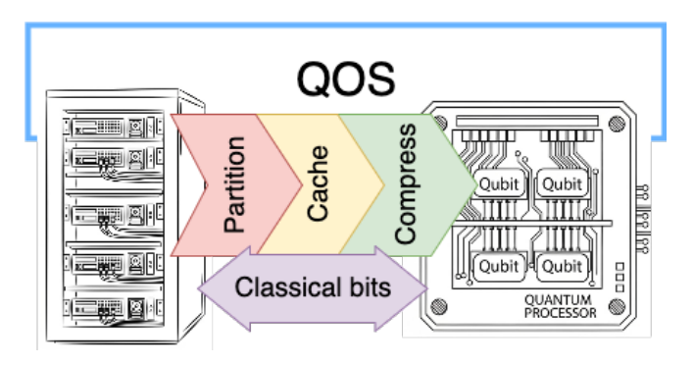

Majority gates (MAJ) improve carry-ripple adders (CRAs) by replacing traditional AND-OR logic with a single gate that outputs true if the majority of its three inputs (A,B,Cin) are true

Quantum Operating System - QOS
QOS operates a pipeline sending processed partitions/sub-circuits to the quantum computer, while simultaneously receiving streams of classical bits from the quantum computer.

The HPC→quantum connection might experience high latency if the quantum computer waits for the HPC to compute the next partition to send.

The first challenge is to compute partitions very fast.
The second challenge is to minimize the processing time of a partition.

The compiler must ensure that, if a similar partition has already been processed, it reuses the cached result by sending it directly to the quantum computer, thereby saving processing time

The HPC→quantum connection might experience low throughput if inefficient data formats are used to communicate the partitions. Example :- OpenQASM string representation of a circuit being too verbose = for a fixed connection bandwidth, the rate of communicated quantum gates/second is low.

Pandora and Cabaliser -- -------

Pandora - transpile utility-scale circuits (massive, grid-connected infrastructure)
(quantum chemistry or Shors algorithm to Clifford+T)
- Pandora processeses quantum circuits and can operate as a cache for these.
- Pandora built using relational database system and is natively multithreaded
- most tasks can easily be parallelized due to data-consistency guarantees that relational databases give in concurrent scenarios

Cabaliser - compiles to a graph state representation of the program
(Clifford+T)
- Graph-state representations of quantum circuits consist of a reduction of the
Clifford components of the circuits to a graph
- Cabaliser can encode graph state circuits in very efficient serialisable bitpacked structures

So how can we achieve low latency and high Thoughtput from using Pandora and Cabaliser?

Partitioning Quantum Circuits

The streamed partitions have to be compatible with constraints imposed by the quantum computer
- maximum T-count
-maximum gate depth or
- number of qubits

Directed Acyclic Graph (DAG) - modeling structure consisting of nodes (variables or tasks) connected by one-way edges that never form a closed loop, ensuring that no path returns to a previous node.

Pandora stores circuits internally as directed acyclic graphs (DAG) which are processed and optimized by custom rewrite rules via pattern matching.

rewrites can be both Sequential and Random. iterating in topological order over the DAG vs accessing gates in random locations of the DAG

So the answer is implemented a partitioning algorithm on top of Pandora.

This proposed algorithm leverages union-find data structures.

A topologically-ordered state is a unique phase of matter characterized by long-range, hidden quantum entanglement, rather than simple, local alignment of particles like ice or magnets.

-> begin by generating the topologically-ordered edge list of (Vi , V_i+1)
-> cache the list into Pandora
-> each Vk is a node of the DAG
-> Each element of list is identified with a directed edge from node Vi to node V_i+1.
->||performed only once.

-> continue by applying the union and find operations and grow node partitions as long as no bounds are exceeded (e.g. the T-count of the partition is lower or equal than the maximum allowed).

-> return the generated partitions

----> union-find algorithm space complexity = O(n) {n is no of nodes in the DAG}
----> Time complexity = O(â(n)) {practically constant– α grows extremely slowly}

IMP
This never perform the in-memory partitioning algorithm on the whole DAG, but rather on time windows of the DAG. We extract batches from the cached edge list and only perform partitioning on one batch at a time in order to reduce the memory footprint

Low-latency transpilations achieved by:
- Taking the repetitive structure of the circuit into account and decomposing only sub-circuits that are not already cached into Pandora (e.g if a circuit contains multiple adders, we only transpile a specific n-bit adder once – Section III-B),

2) Using multi-threaded transpilation of the circuits DAG. The speedup is obtained by assigning sub-DAGs to separate transpilation processes.

<->Transpilation is streamlined to keep memory requirment low

Non-Clifford sequence cache keys in quantum computing are used to manage, store, and reuse optimized sequences of non-Clifford gates (such as T, CS, or Toffoli gates) that are synthesized to approximate target unitaries within a specified precision (ϵ)

Extraction and Partitioning. The first refers to the process of assembling the Pandora information into a standardized format such as OpenQASM, whereas the latter is the process of finding architecture-aware sub-circuits.

In practice, partitioning and extraction are repeated multiple times, achieving low latency HPC→quantum connections

MAJ (Majority) and UMA (Unmajority and Add) gates are specialized building blocks used to construct efficient quantum ripple-carry adders.

Our system integrates Pandora for caching and partitioning and Cabaliser for efficient graph-state compression. We presented numerical evidence that these techniques can yield a five-orders-of-magnitude reduction in latencies during the automatic transpilation of extremely large quantum circuits

https://www.osti.gov/servlets/purl/2204147

https://arc.net/folder/8031BFFF-74DF-40D9-B239-4C2E59FD2A30

https://arc.net/folder/93558738-DE46-41F1-8B29-953DC3331CD5

Cache outputs tracing:
1. Primary tracing: event-level software cache telemetry

The core trace is row-level logging around the repo’s software cache / workload reuse behavior, not physical CPU cache lines.

The main files are:

qmc_simulation_log.csv
cache_access_log.csv
qmc_cache_patterns.csv
repeated-workload outputs in the newer workload-study phase

At this level, each pricing/workload event records things like:

cache key
exact cache hit vs miss
similarity score
feature hash
wall-clock timing
per-access timing fields such as lookup and compute time

So the primary system is:
exact-key reuse + similarity/reuse metadata + timing logs.

That is the real source of truth for current local cache-study behavior.

2. Secondary tracing: rolling-window pattern summaries

On top of raw event logs, the repo builds window summaries in trace_windows.csv.

Those windows aggregate:

exact hit rate
miss rate
similarity hit rate
mean reuse distance
working set size
locality score
burst score
periodic score
mean wall-clock time

This is where the repo starts turning raw event logs into pattern candidates.

So the current pattern-detection logic is more like:

event stream → rolling window summaries → reuse/locality/burst/periodic metrics

3. Tertiary embedding: polar coordinate representation

Then, on top of the window summaries, the repo computes a polar/3D embedding.

That lives in:

trace_polar.py
trace_polar_embeddings.csv

Fengguang Song — Associate Professor of Computer Engineering. His listed research areas are high performance computing, advanced parallel algorithms, scalable parallel and distributed systems, and automated performance analysis and optimization. He also teaches/has taught Parallel GPU Computing, Operating Systems, and Computer Architectures, which is very close to the kind of cache-observability and workload-optimization discussion you want. For your topic, he is probably the best first conversation if you want to talk about how to design experiments, instrument workloads, analyze performance traces, and think about cache behavior in a serious HPC/systems way.

Andrew Lukefahr — Assistant Professor of Intelligent Systems Engineering. His work is centered on FPGA security at the circuit and architecture levels, and his background is explicitly in computer architecture. Even though his public-facing research emphasis is security/FPGA, he is still a strong person for a deep conversation about low-level architecture, hardware-aware system design, tracing concerns near the architecture boundary, and what would or would not count as credible cache-level claims. He is the better fit if you want the discussion to lean more toward architecture realism than broad HPC workflow design.

A useful third person is Martin Swany. He is Chair of Intelligent Systems Engineering, and the available IU material lists his research interests as high performance computing, software-defined networking, and FPGA security. He is a good choice if your conversation is less “how do I measure cache traces in one experiment?” and more how should I frame an HPC-and-systems research agenda, what belongs on local hardware versus cluster hardware, and how to connect your work to Big Red 200 and broader systems infrastructure.

My practical ranking for your exact topic would be:
1. Fengguang Song — best first meeting
2. Andrew Lukefahr — best second meeting
3. Martin Swany — best for broader HPC positioning

